Q1:

Create an Application and Store the Data in database using Hibernate / JPA 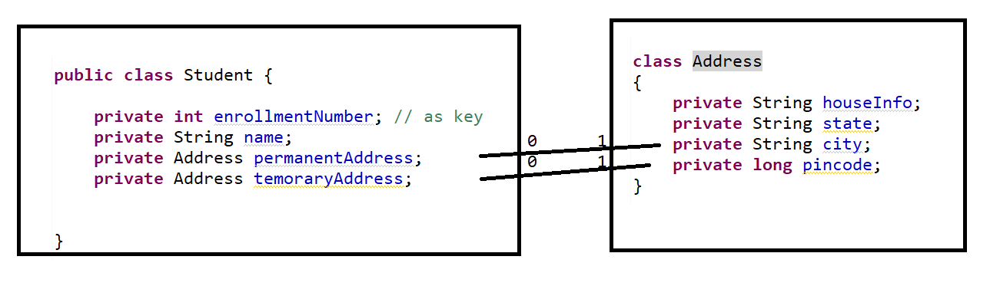

Q2: Store following Entities by using Hibernate Single Table Strategy

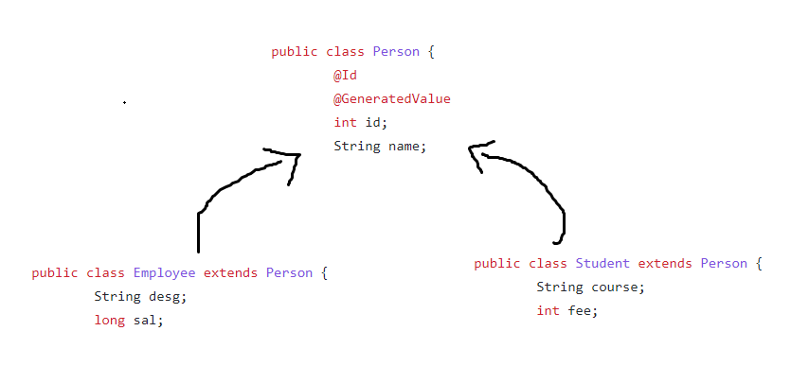

Note : Discriminator Value for Person should be P , for Employee should be E and for Student should be S, and ID value have to be started from 1100 onwards.